MODULE 10:-KUBERNETES

Container Orchestration Tool – Kubernete
SUBMITTED BY :- CHANDAN YADAV KS
SUBMITTED TO :- VIKUL
DATE OF SUBMISSION :- 17-07-2025

1. L1 - Create Deployment Controller Object to Deploy the Application Image Created in Docker Module and Expose it to the Internet
Step 1: Launch 3 EC2 Instances (t3 medium and enable all traffic )
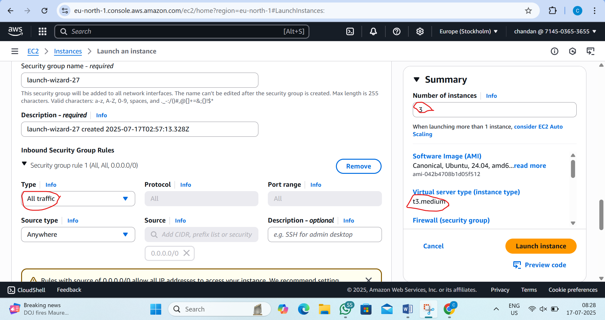
Step2:name the instance as 1 is master and another 2 is node1 and node2
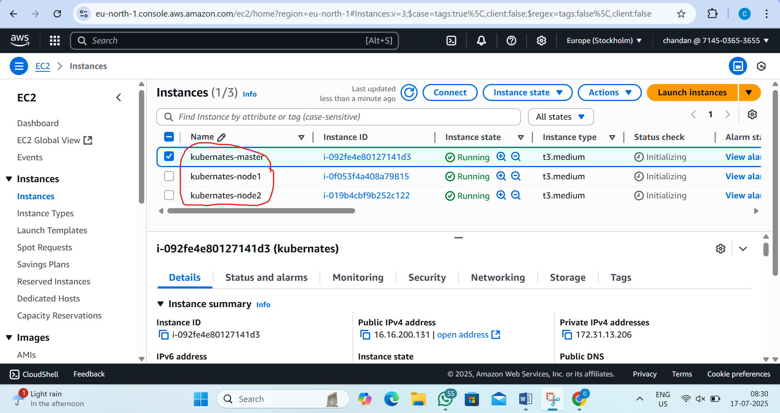

Step3:now connect the master and nodes machine
now in master machine install kubernates by the following steps
by the commands;-
i) sudo su
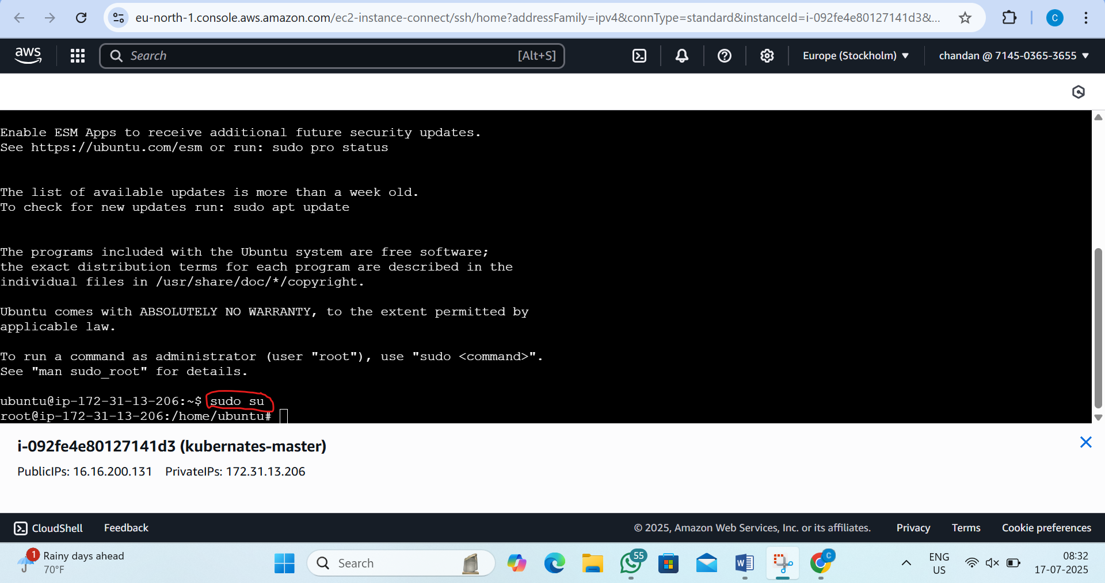
ii) wget https://raw.githubusercontent.com/akshu20791/Deployment-script/main/k8s-master.sh
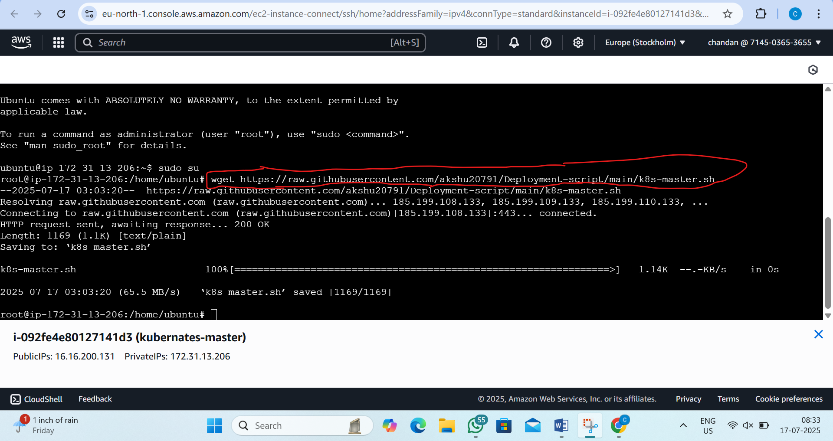

iii)ls -l and ls
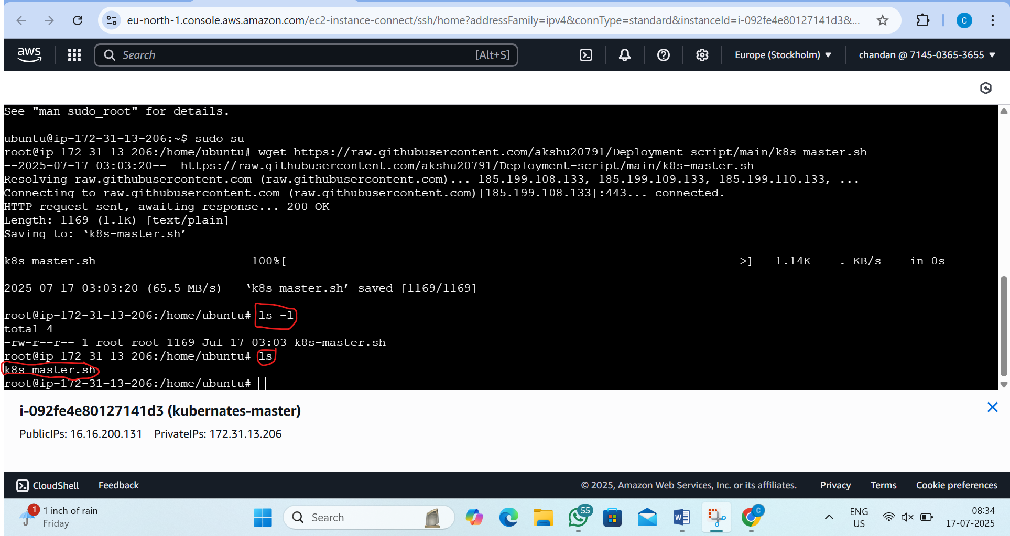
iv) chmod 777 k8s-master.sh and ls -l
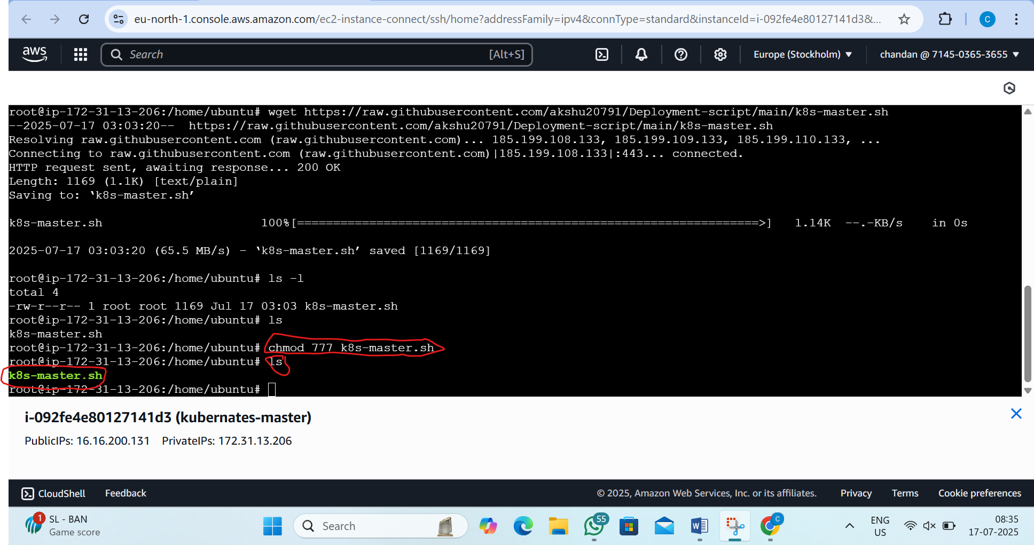

V)./k8s-master.sh
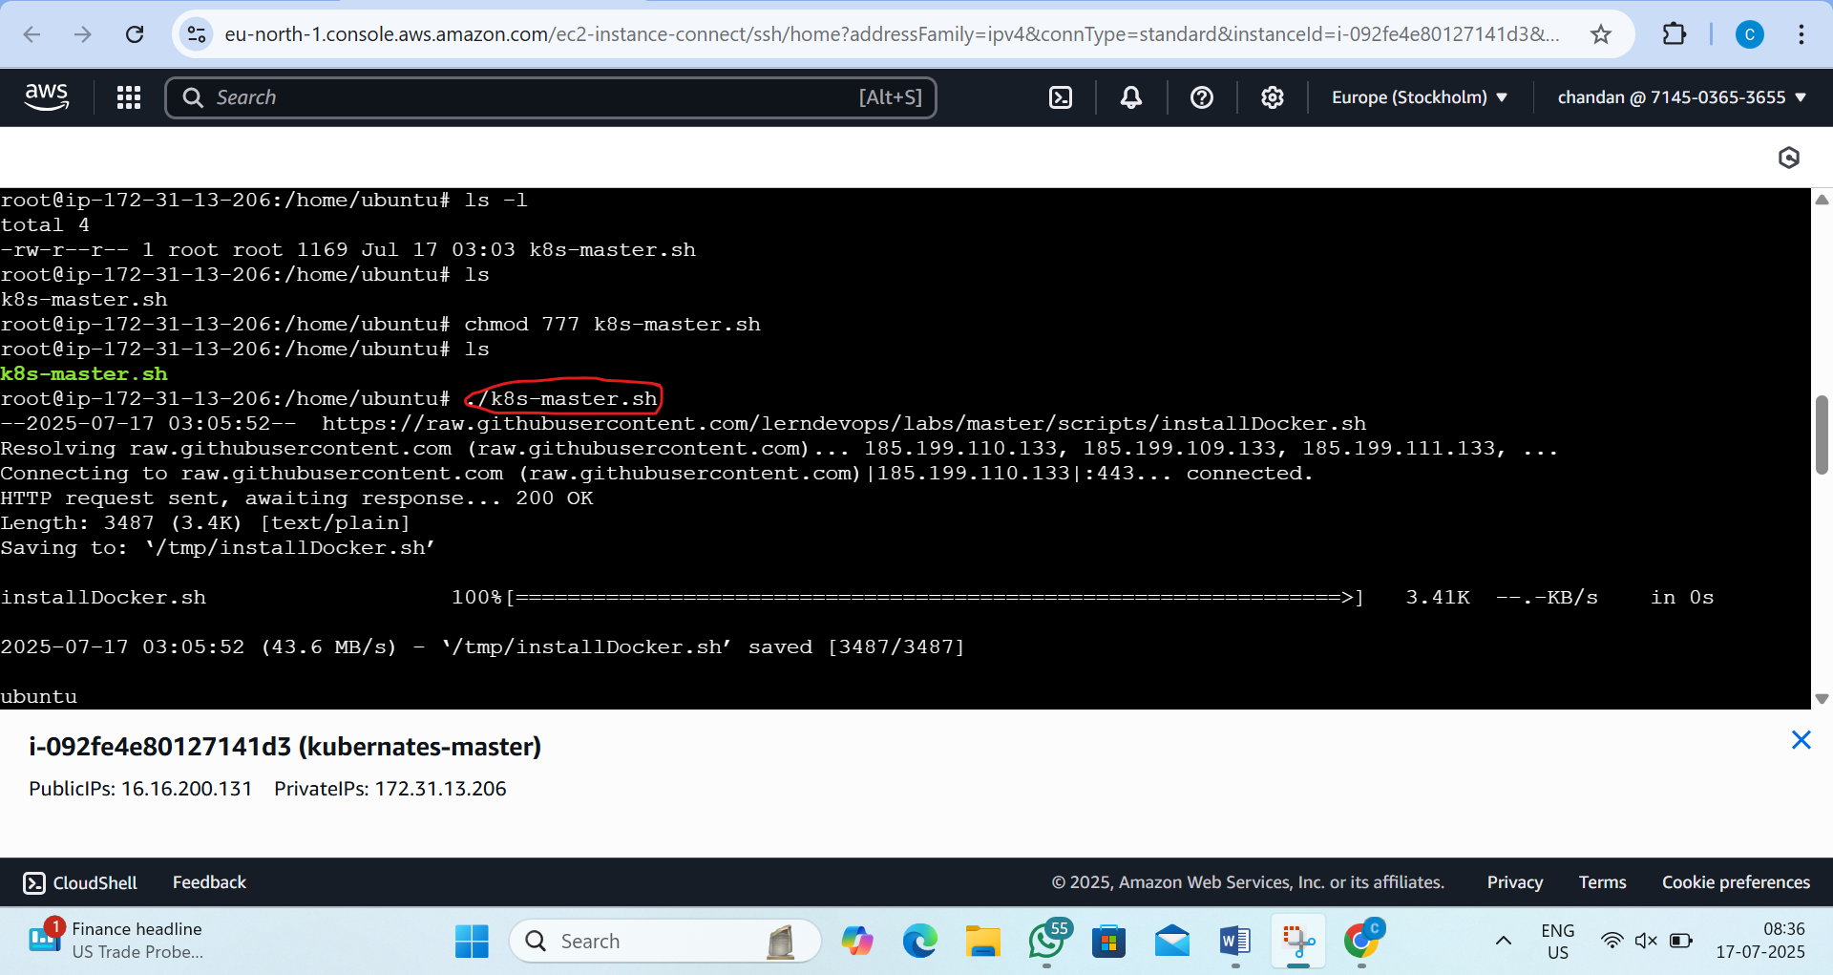

Step4:now go to nodes and follow this command(I will display screenshot for node 1 only but both the node we want to follow the commands)
i)sudo su
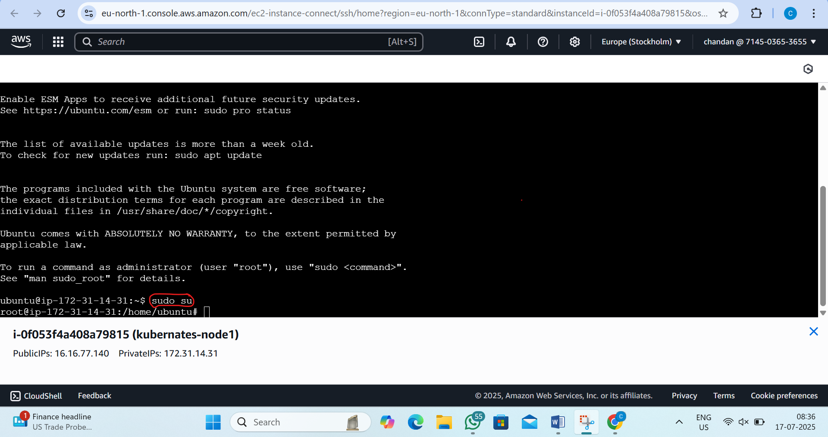

ii) wget https://raw.githubusercontent.com/akshu20791/Deployment-script/main/k8s-nodes.sh
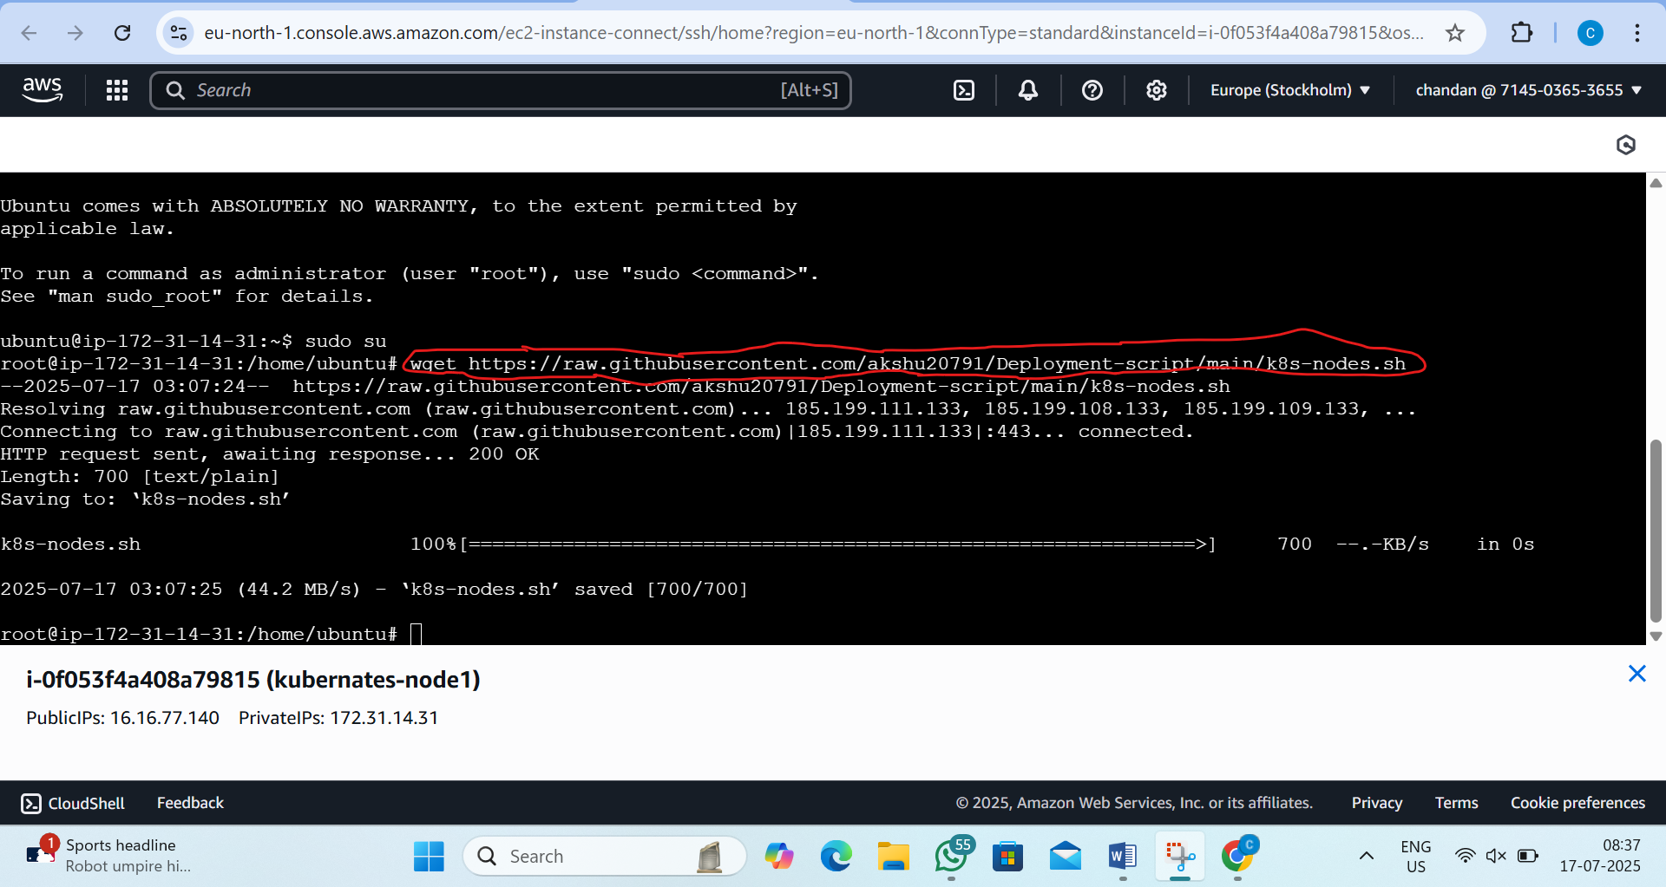

iii)ls and ls-l
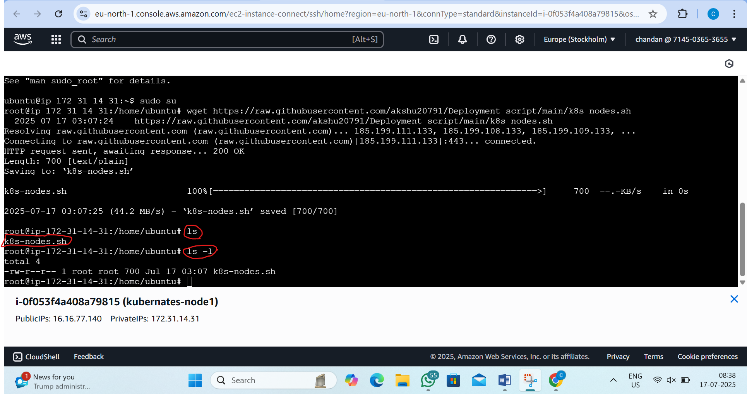

iv) chmod 777 k8s-nodes.sh
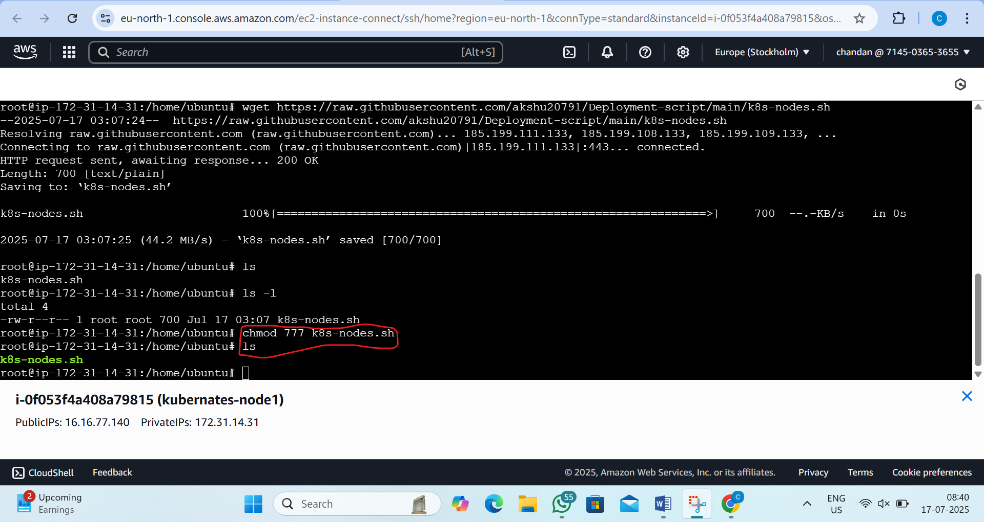
v) ./k8s-nodes.sh
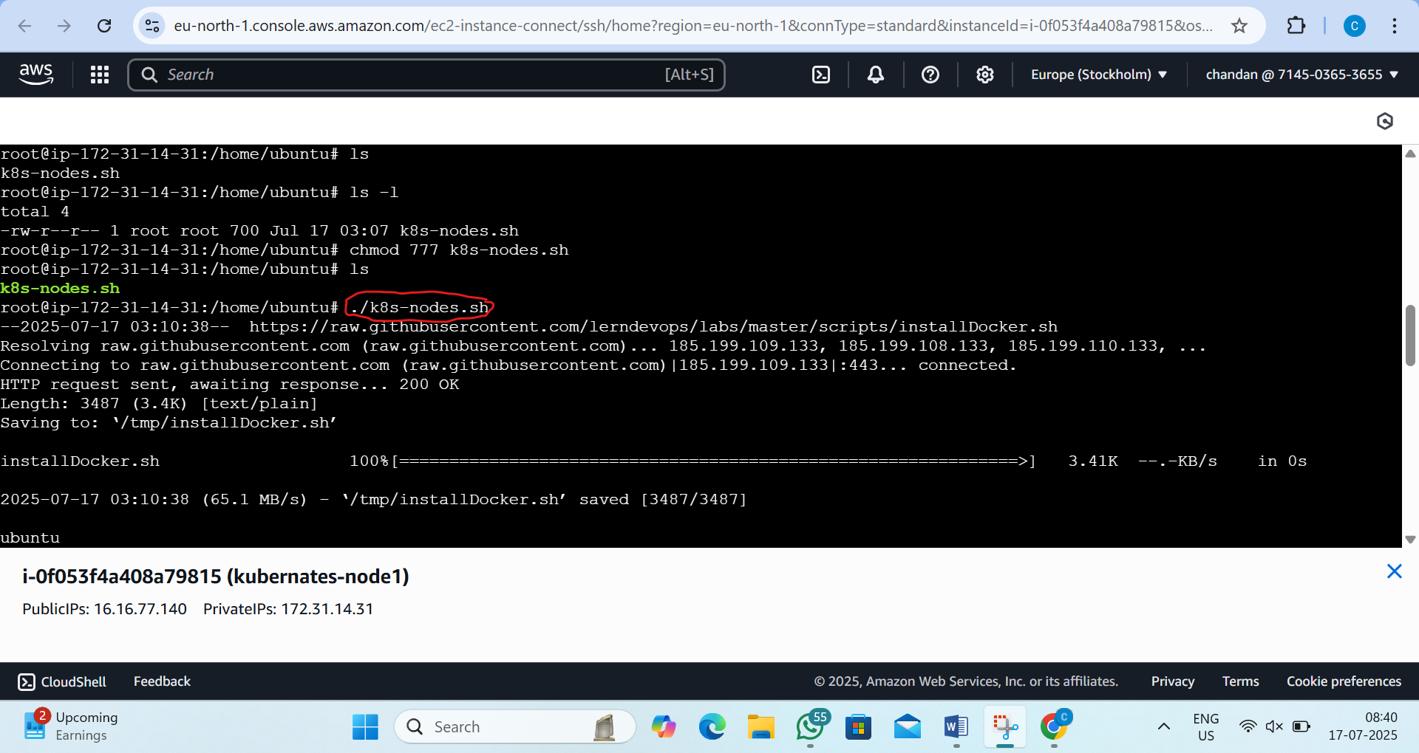

vi)run this command in the node
modprobe br_netfilter
echo 1 > /proc/sys/net/bridge/bridge-nf-call-iptables
echo 1 > /proc/sys/net/ipv4/ip_forward
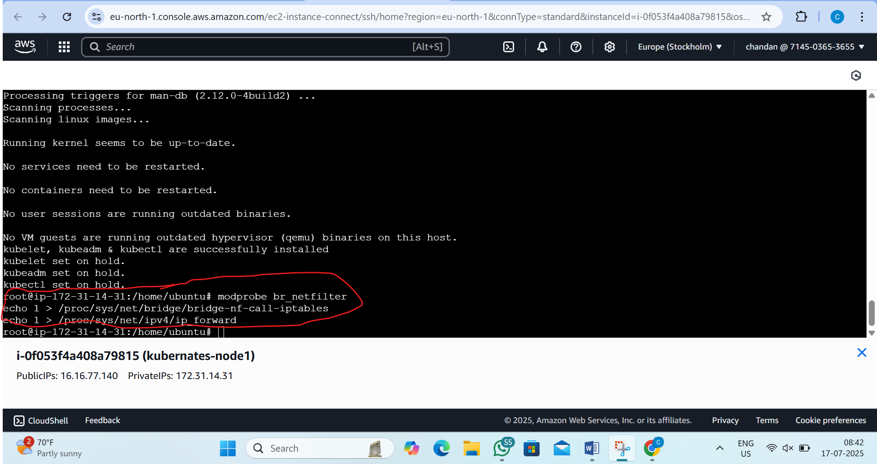
step5:now go to master machine and generate token in master
by the command:- kubeadm token create --print-join-command
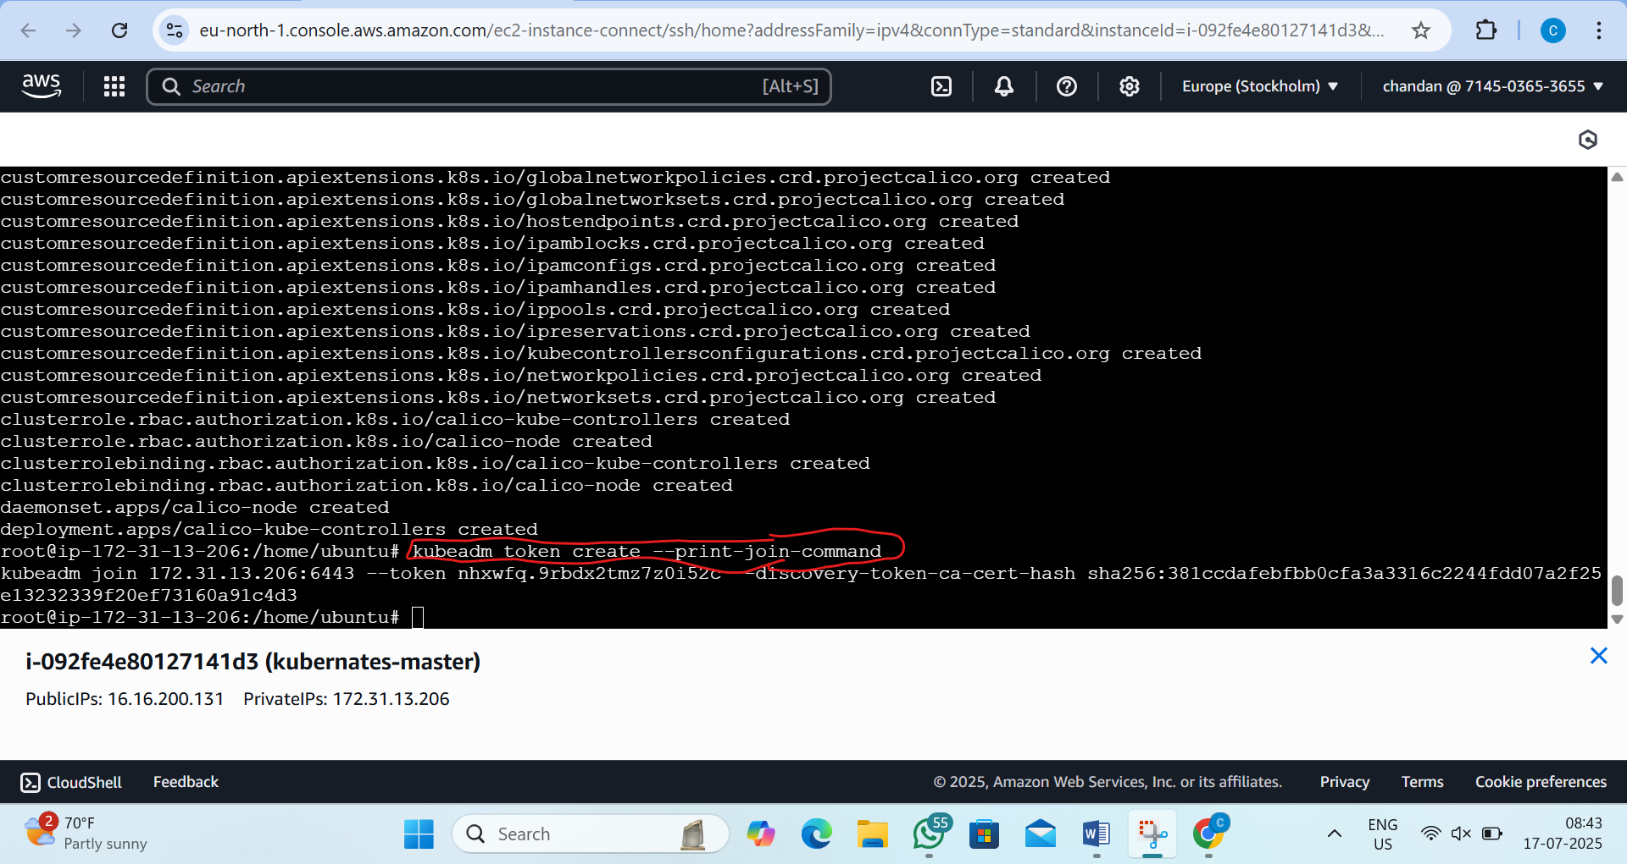

Step6:now go to node and do copy the token and paste it in notepad and after that in the command you will see 6443 written ...after that paste ------cri-socket unix:///var/run/cri-dockerd.sock
this we want to paste in node:- kubeadm join 172.31.13.206:6443 --cri-socket unix:///var/run/cri-dockerd.sock --token nhxwfq.9rbdx2tmz7z0i52c --discovery-token-ca-cert-hash sha256:381ccdafebfbb0cfa3a3316c2244fdd07a2f25e13232339f20ef73160a91c4d3
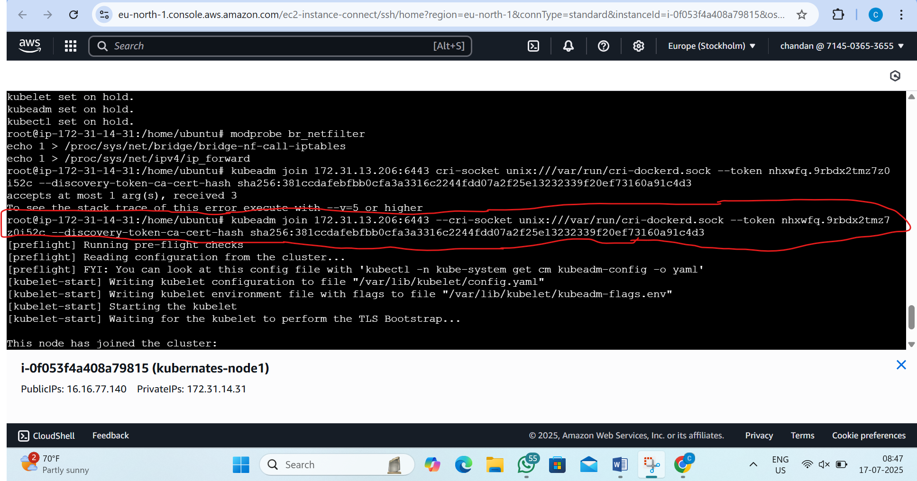
Step7:now return to master and see the 2 nodes
by the command:- kubectl get nodes
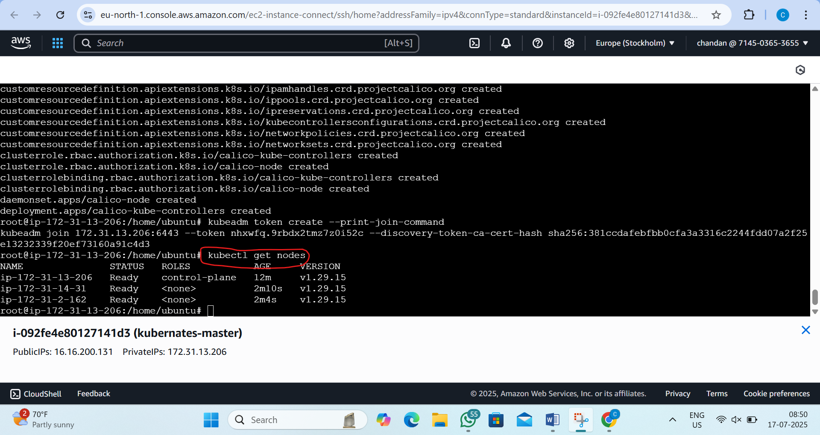

STEP 8: Create Apache Deployment
On master node
by the command:-vi apache-deployment.yaml
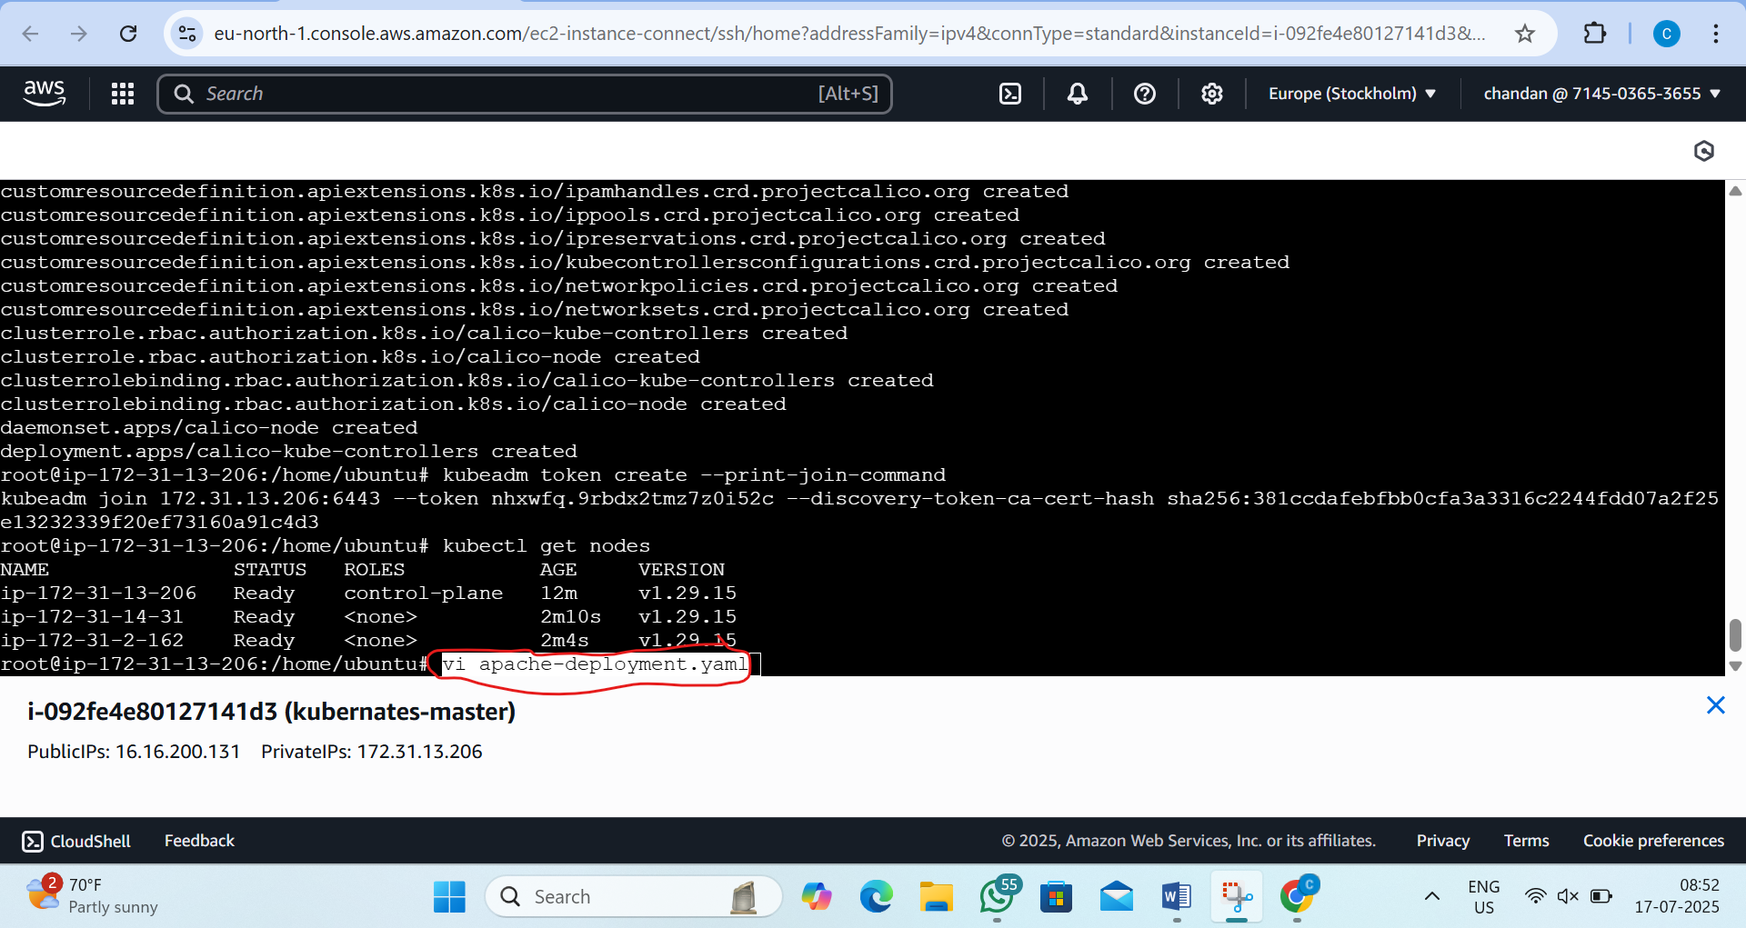
Step 9:now press I and paste the script and press esc +:wq and press entre
script is:-
apiVersion: apps/v1
kind: Deployment
metadata:
name: apache-deployment
spec:
replicas: 2
selector:
matchLabels:
app: apache
template:
metadata:
labels:
app: apache
spec:
containers:
- name: apache
image: httpd
ports:
- containerPort: 80
---
apiVersion: v1
kind: Service
metadata:
name: apache-deployment
spec:
type: NodePort
selector:
app: apache
ports:
- protocol: TCP
port: 80
targetPort: 80
nodePort: 30036
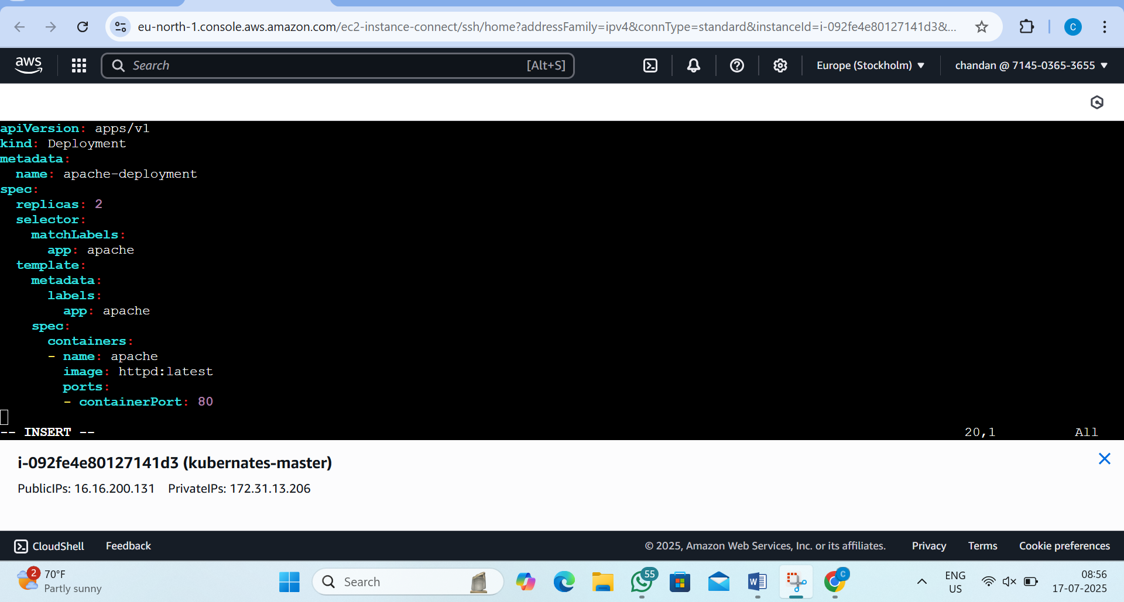

Step10:now deploy the ymal file in the master
by the command:- 1)kubectl apply -f apache-deployment.yaml
2)kubectl get deployments
3)kubectl get pods
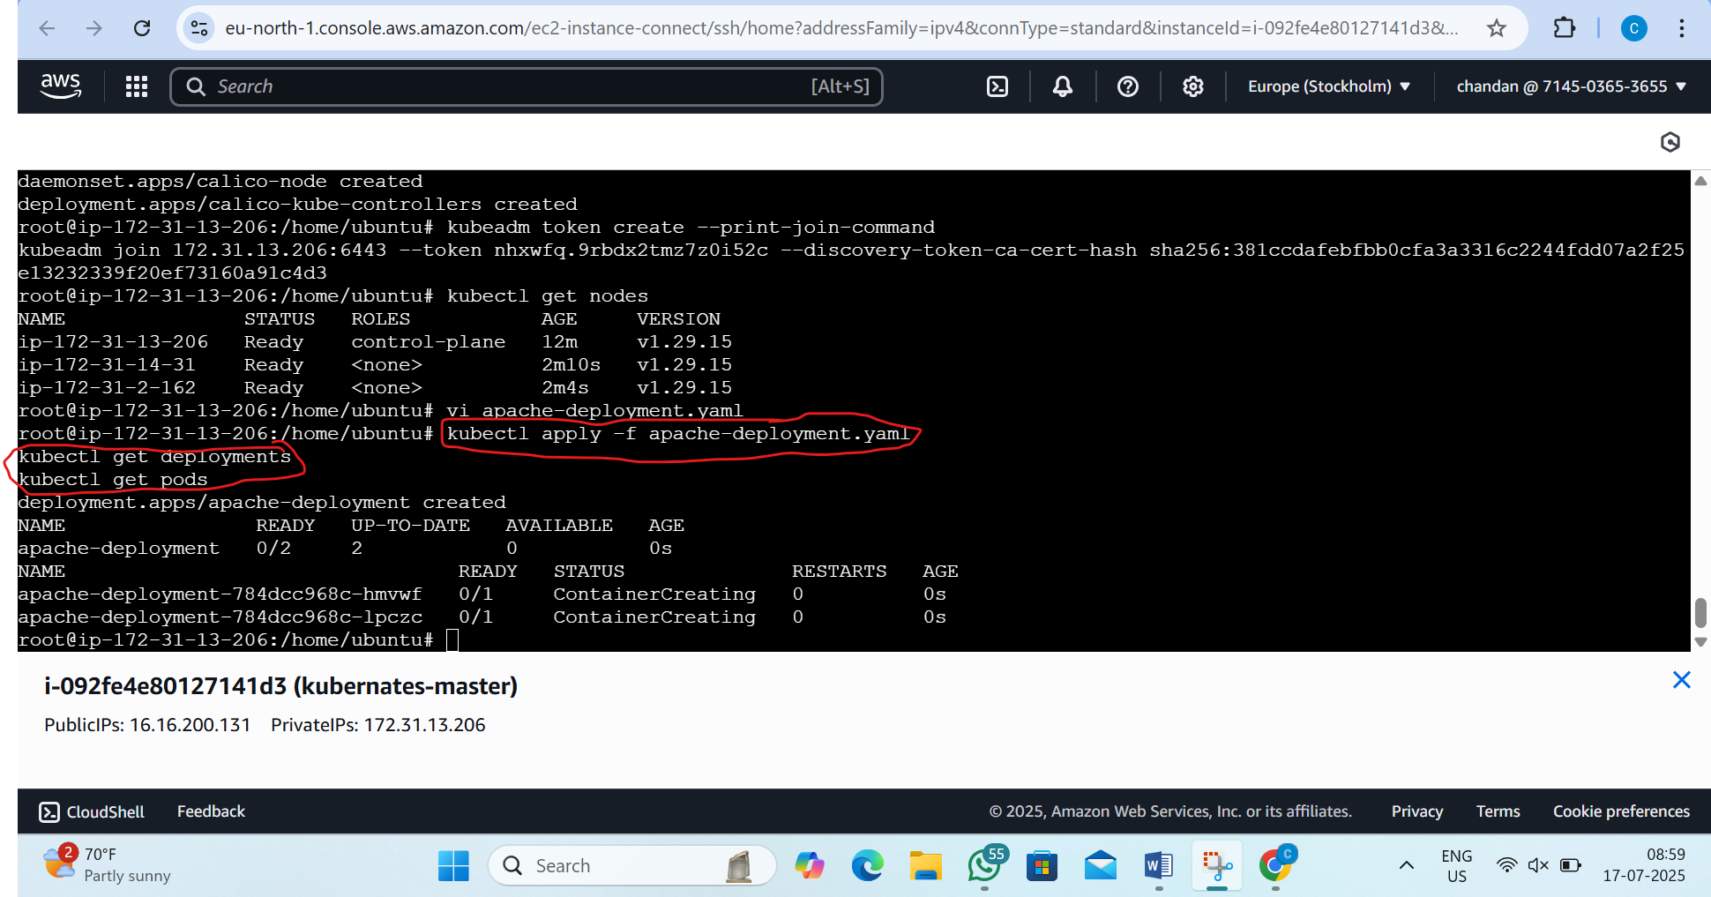

Step11:- Expose Apache with NodePort
by the command:- kubectl expose deployment apache-deployment --type=NodePort --port=80
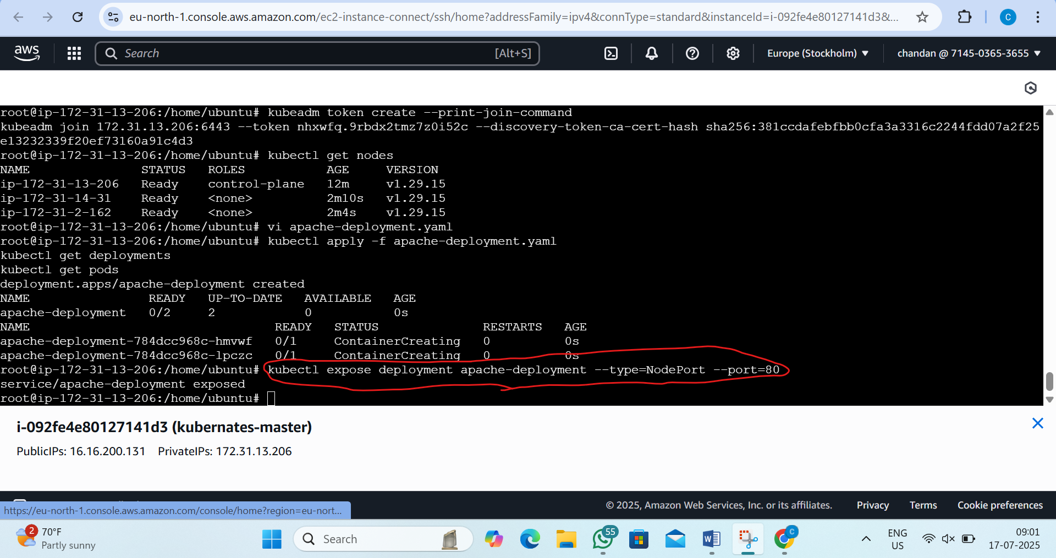
Step12:now run
by the command:- kubectl get svc
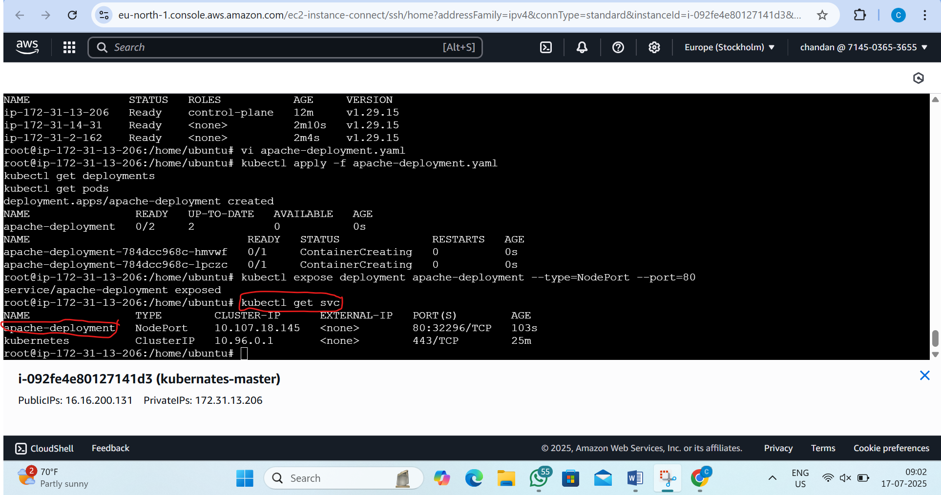
Step13: Access from Browser and see the in which node if running
by the command :- kubectl get pods -o wide
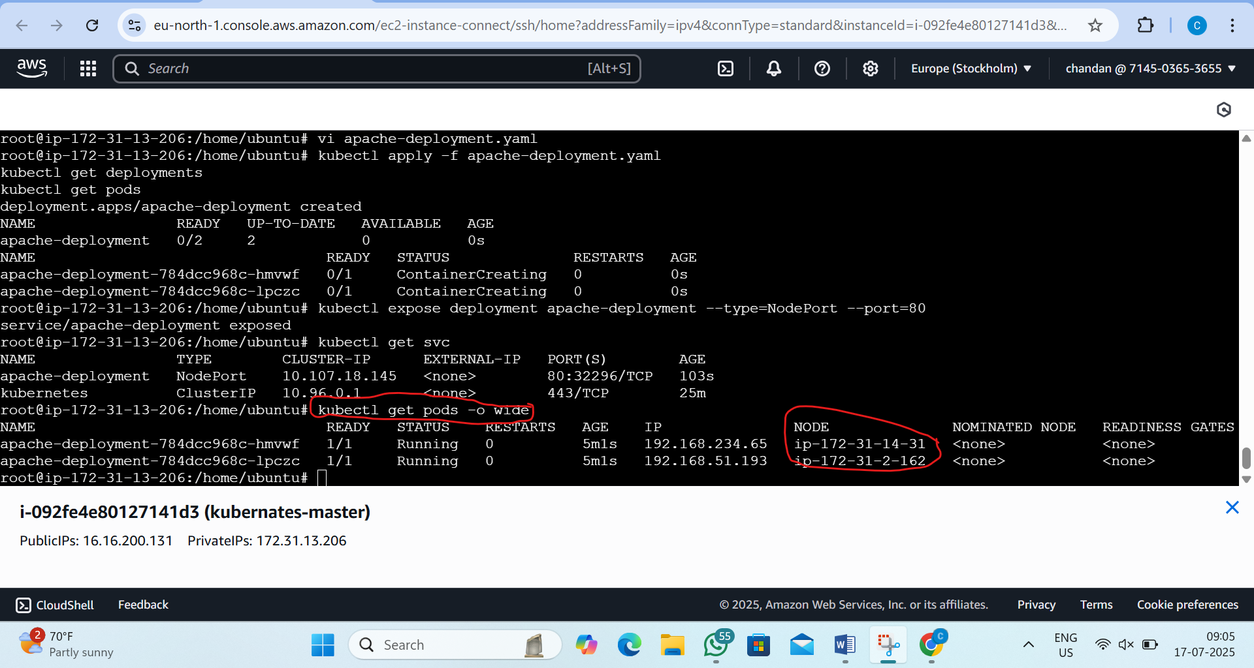

Step14:now open browser and see the output
by type in brower: http://<worker-public-ip>:<NodePort>
Hear: http://16.16.77.140:30036/
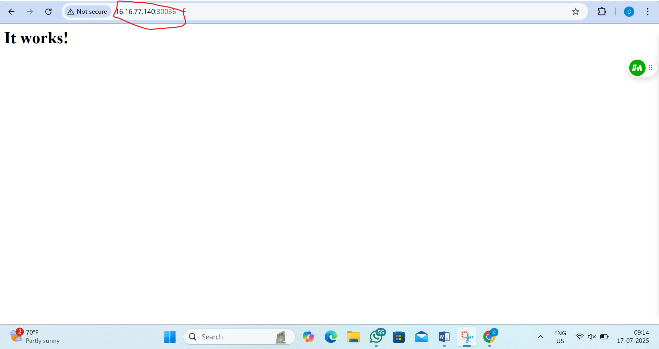

2. L2 - Scale-up and Scale-Down the Pods Deployed
Step1:now see the deployment
by the command:- kubectl get deployments
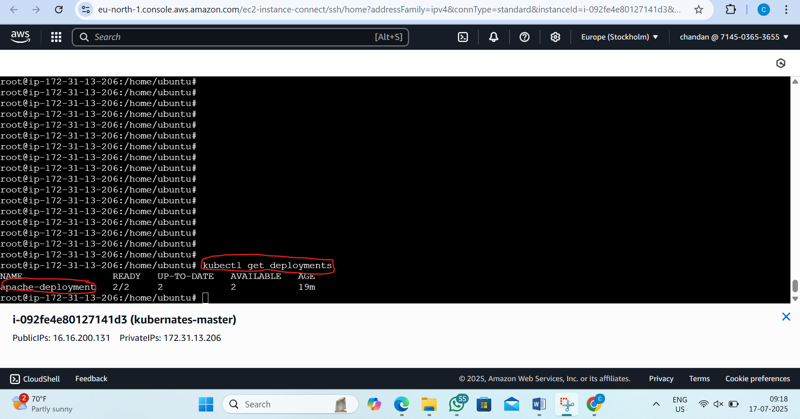

Step 2: Scale Up the Pods (e.g., from 2 to 5)
by the command: kubectl scale deployment apache-deployment --replicas=5
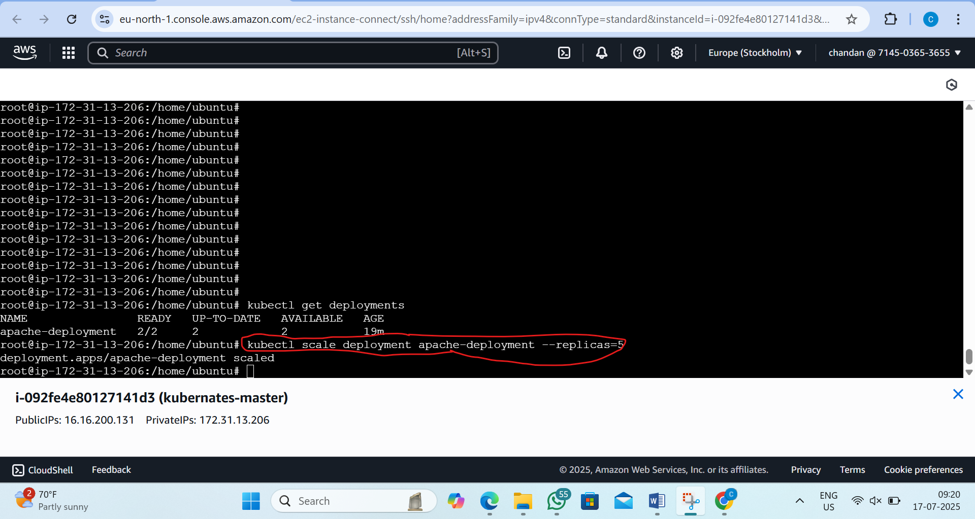

Step3:now verify the pods
by the command:- kubectl get pods -o wide
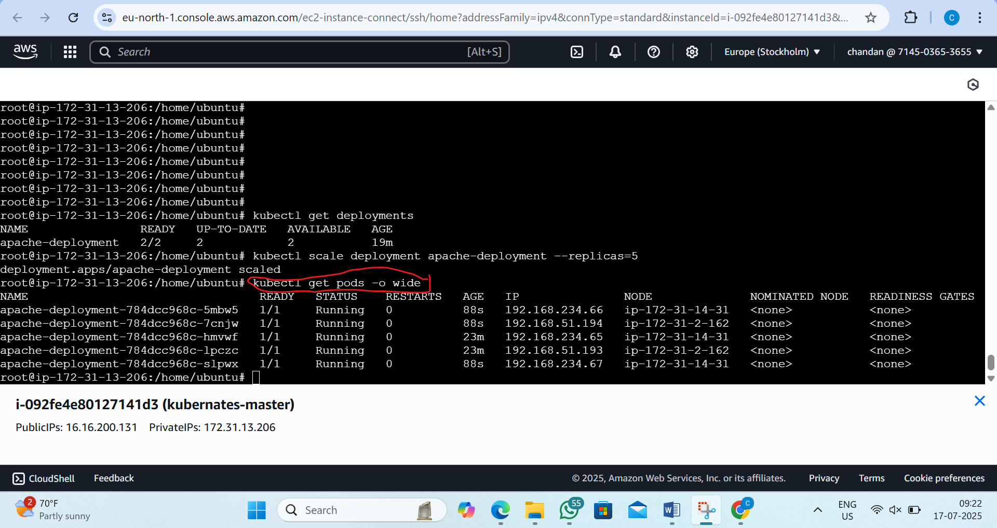
Step4:- Scale Down the Pods (e.g., back to 2)
by the command:- kubectl scale deployment apache-deployment --replicas=2
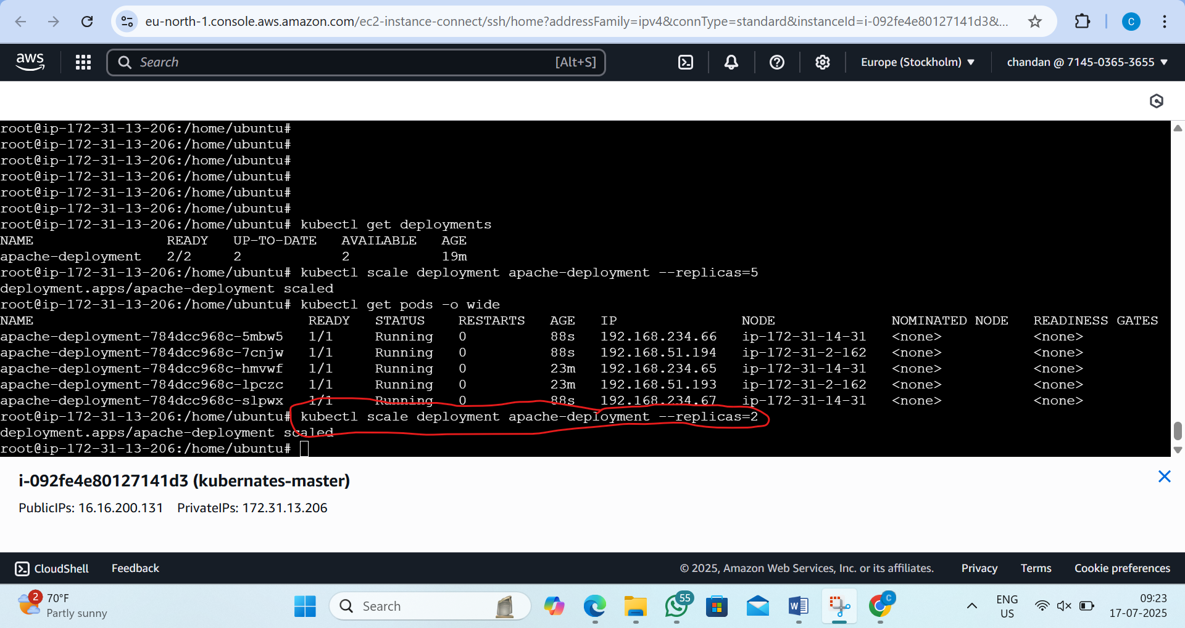

Step5:now verify again the pods
by the command: kubectl get pods -o wide
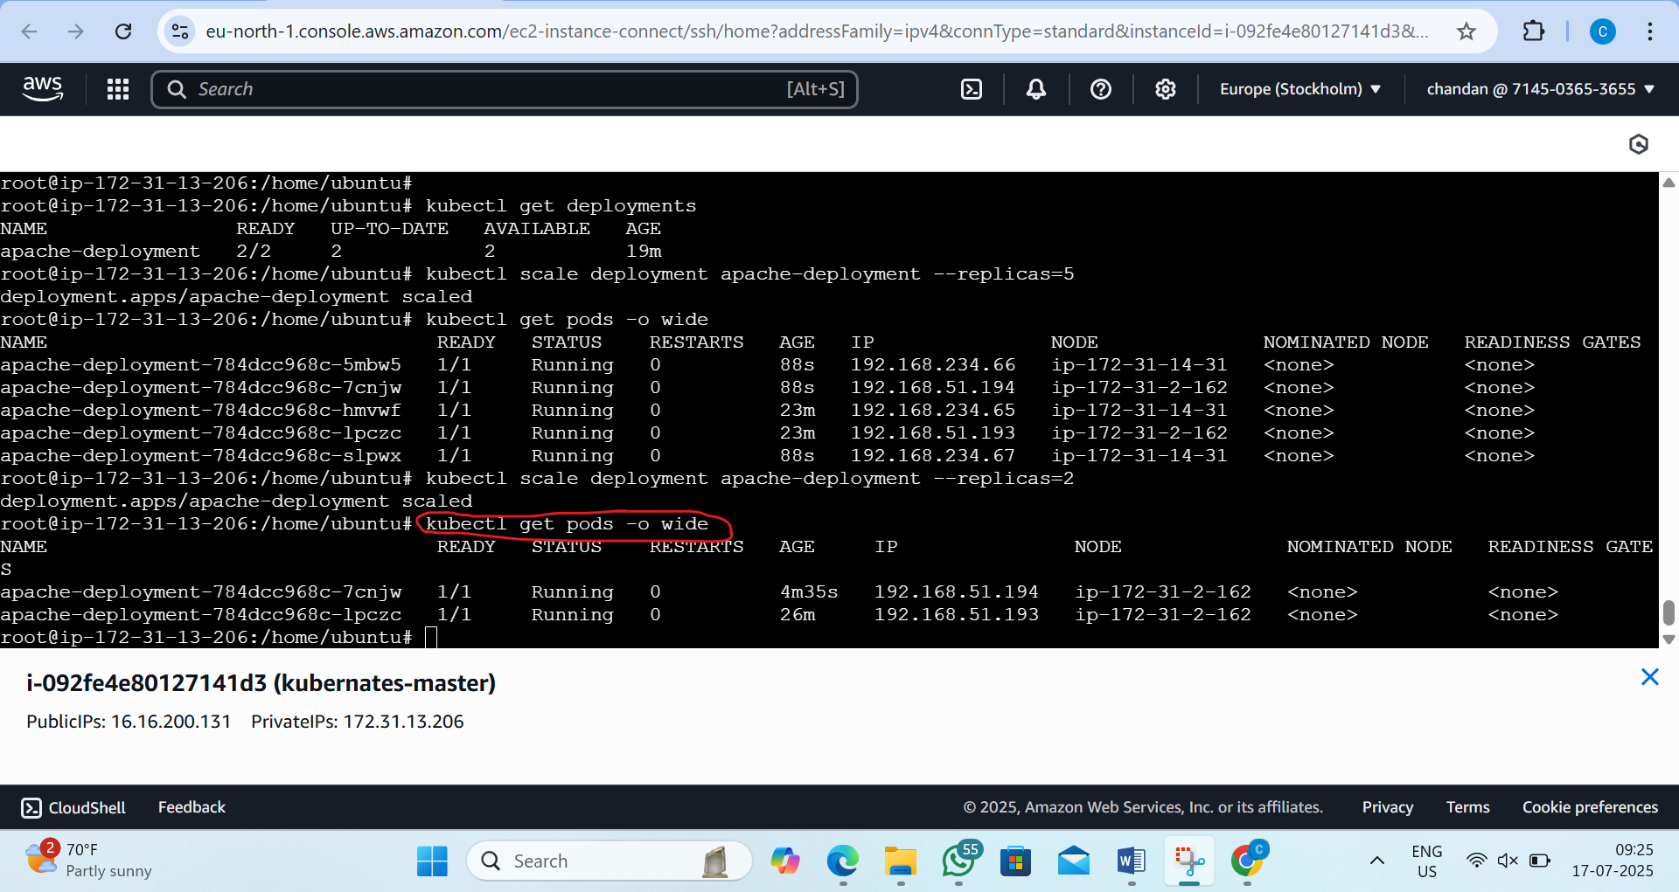
Step 6:finally conformation see the depolyment
by the command:- kubectl get deployment apache-deployment
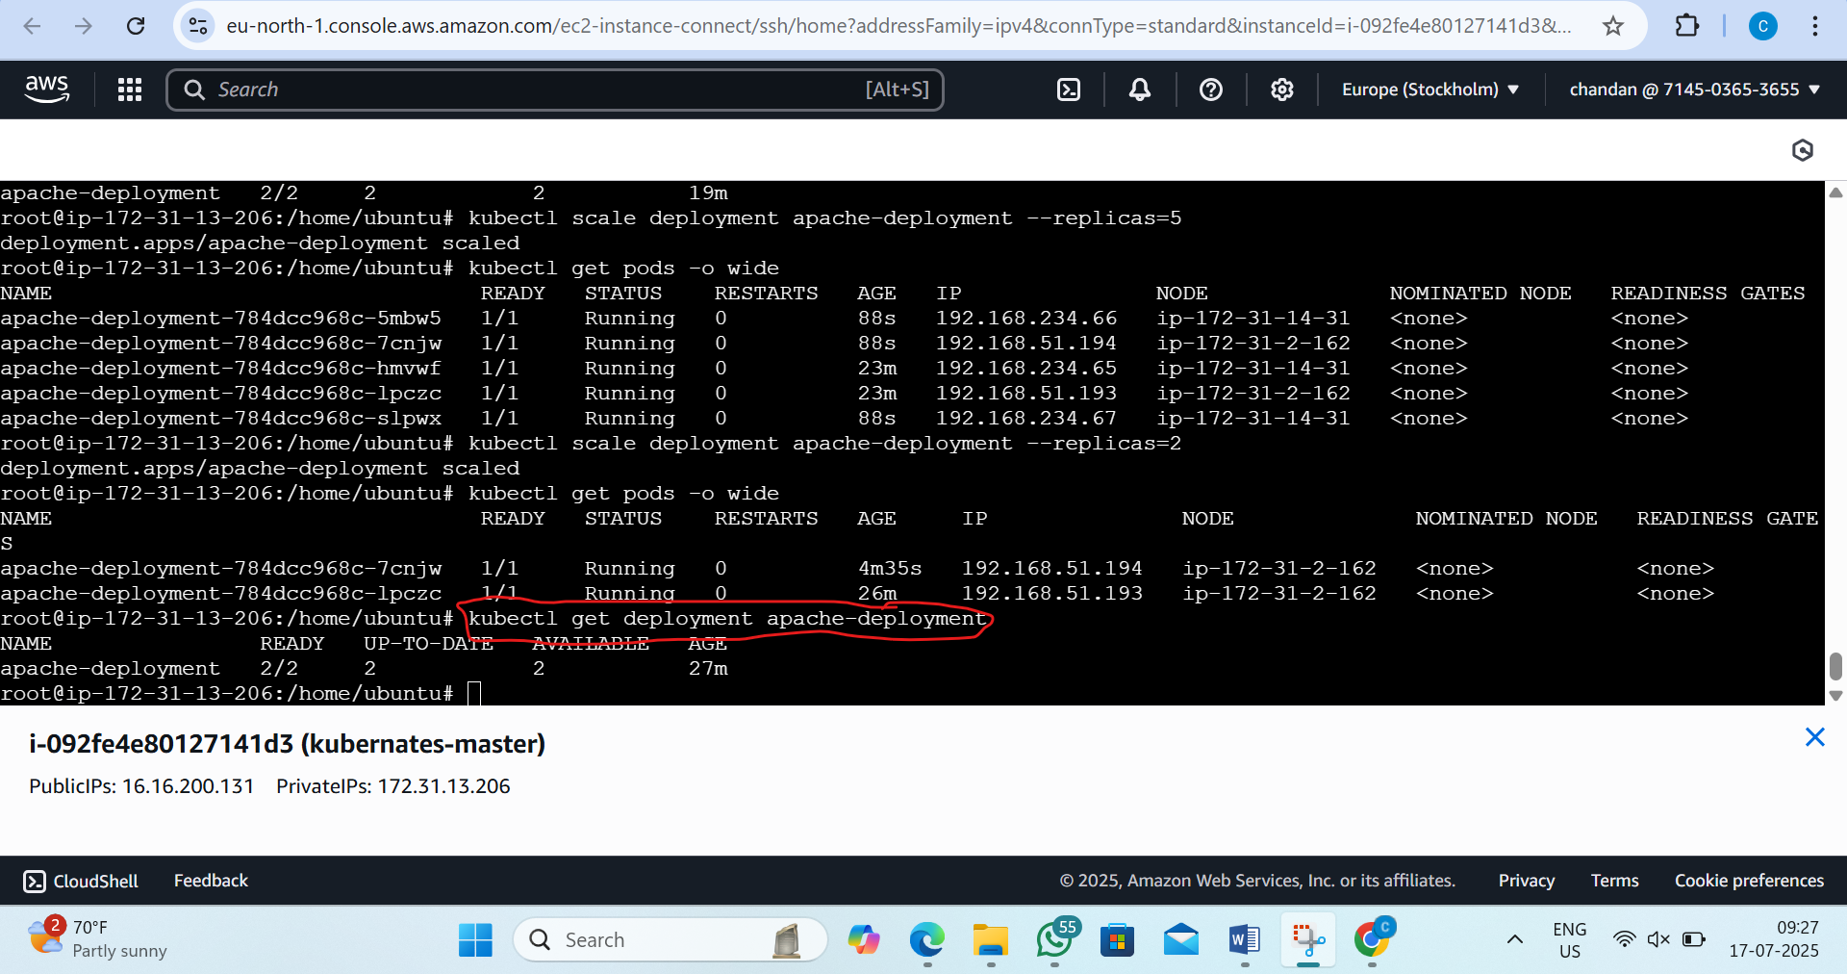

3. L3 - Implement Rolling-Update Strategy to Upgrade the Application Image from V1.0 to V1.1
Step 1: Create Initial Deployment (v1.0)
i)create or edit a file
by the command: vi apache-deployment.yaml
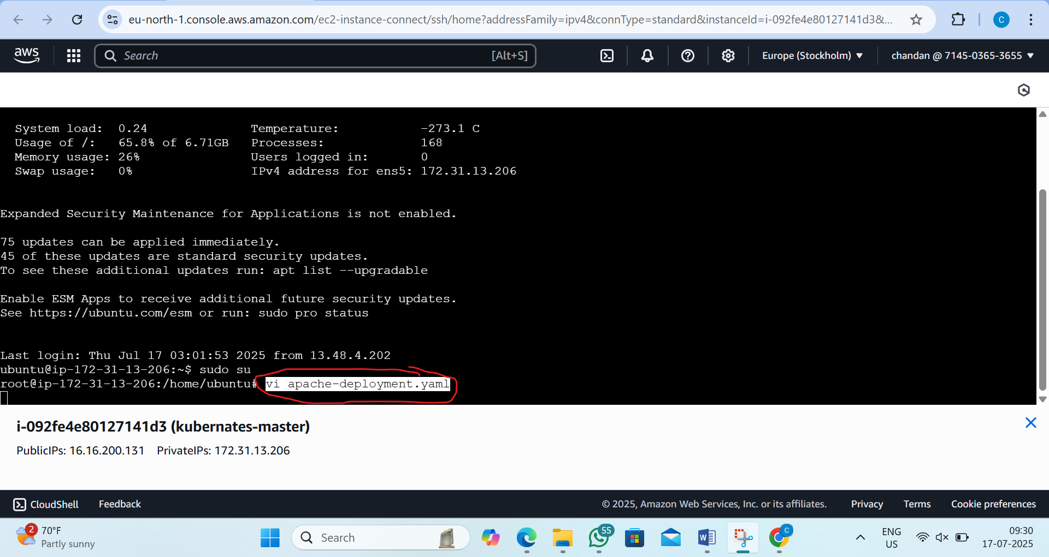
ii)now paste the script inside it
apiVersion: apps/v1
kind: Deployment
metadata:
name: apache-deployment
spec:
replicas: 2
strategy:
type: RollingUpdate
rollingUpdate:
maxUnavailable: 1
maxSurge: 1
selector:
matchLabels:
app: apache
template:
metadata:
labels:
app: apache
spec:
containers:
- name: apache
image: httpd:2.4 # This is your simulated v1.0
ports:
- containerPort: 80
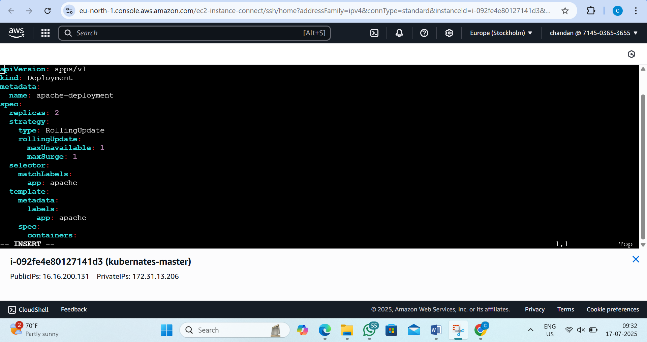
iii)now appy
by the command: kubectl apply -f apache-deployment.yaml
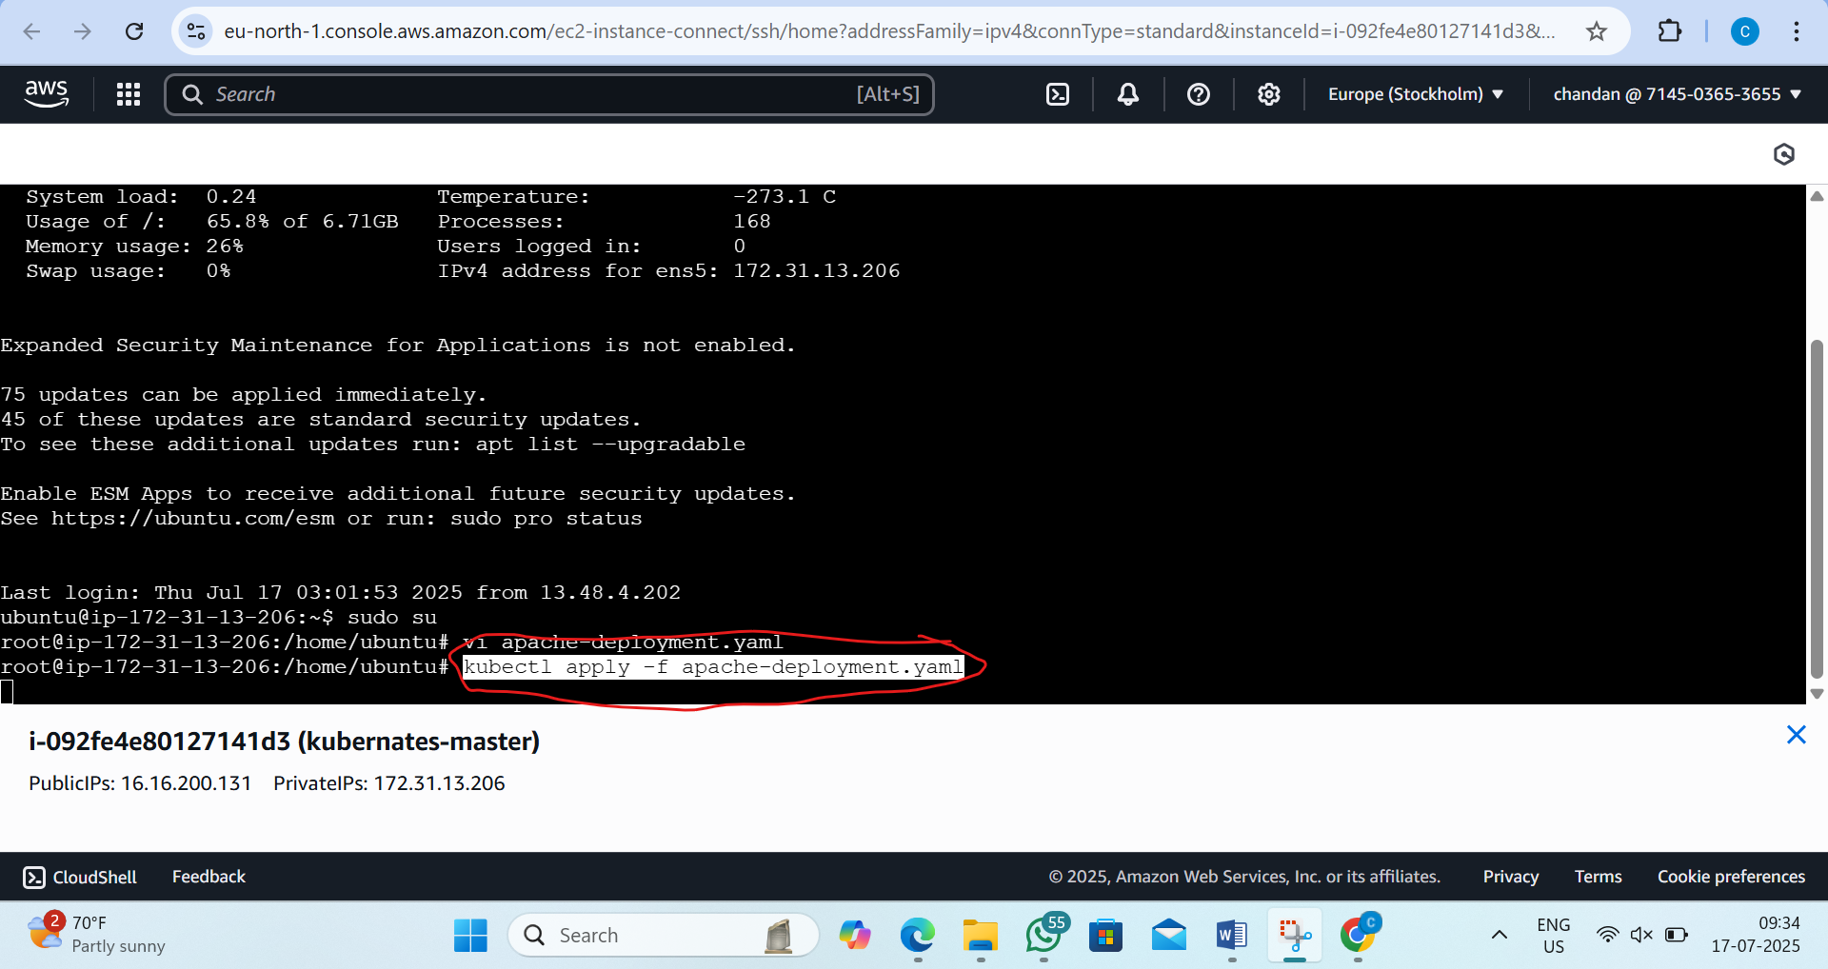

Step2: Check Pods Are Running with v1.0 (httpd:2.4)
by the command: 1)kubectl get pods -o wide
2)kubectl describe deployment apache-deployment | grep Image
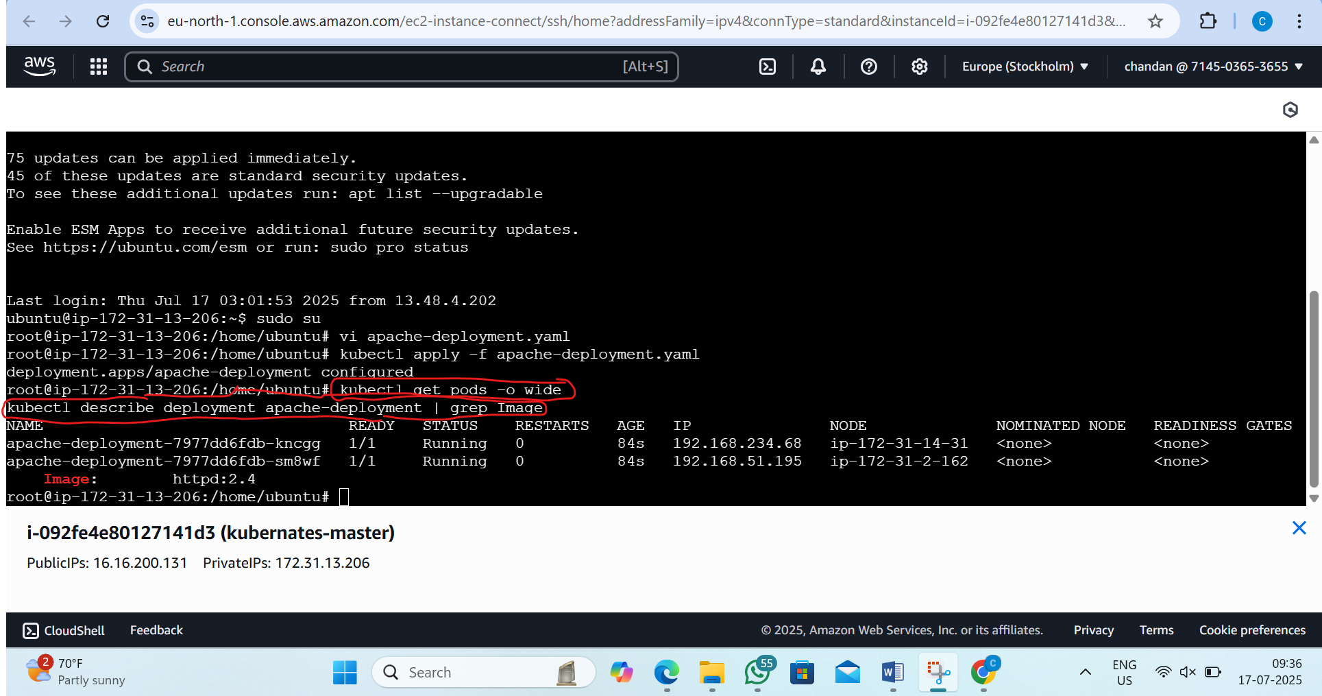
Step3: Perform Rolling Update to v1.1 (httpd:2.4.58)
By the command:- kubectl set image deployment apache-deployment apache=httpd:2.4.58
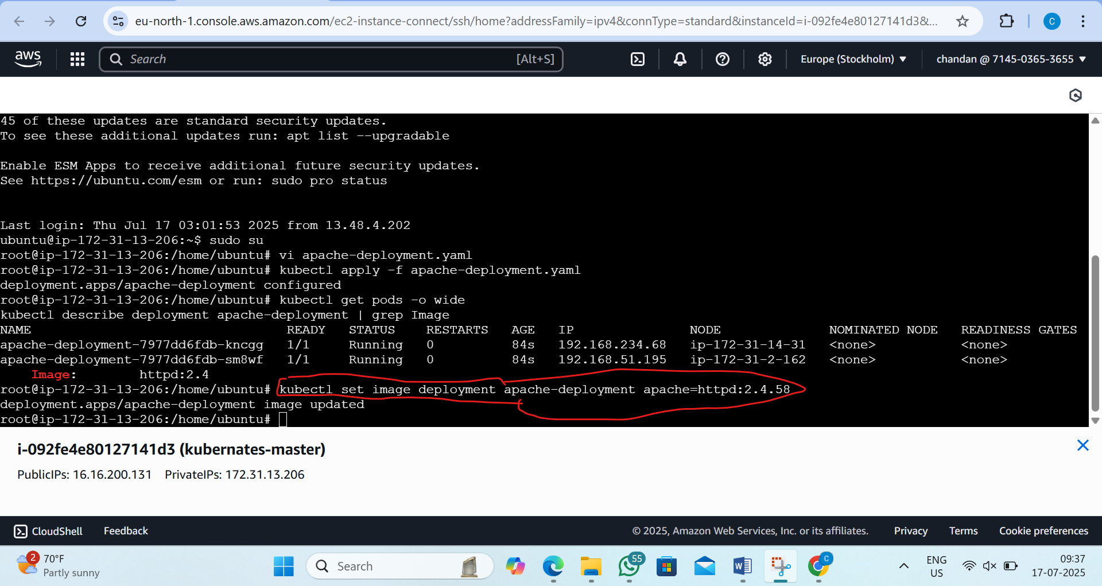

Step4:now Monitor the Rolling Update
by the command:- kubectl rollout status deployment apache-deployment
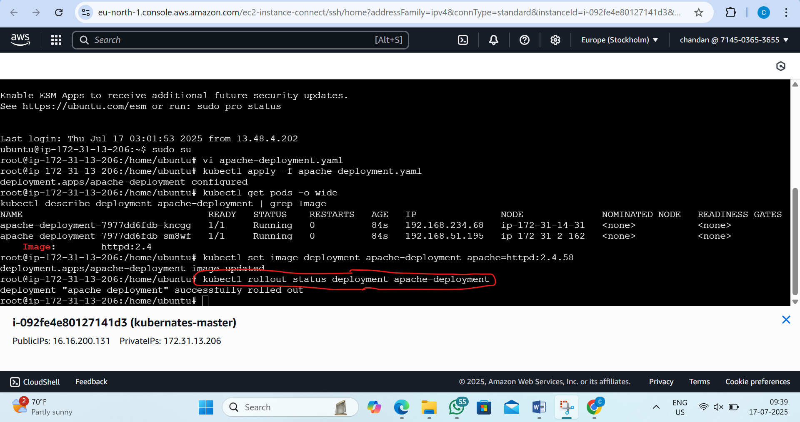
Step5: Confirm Update Completed
i)list all the pods
by the command:- kubectl get pods
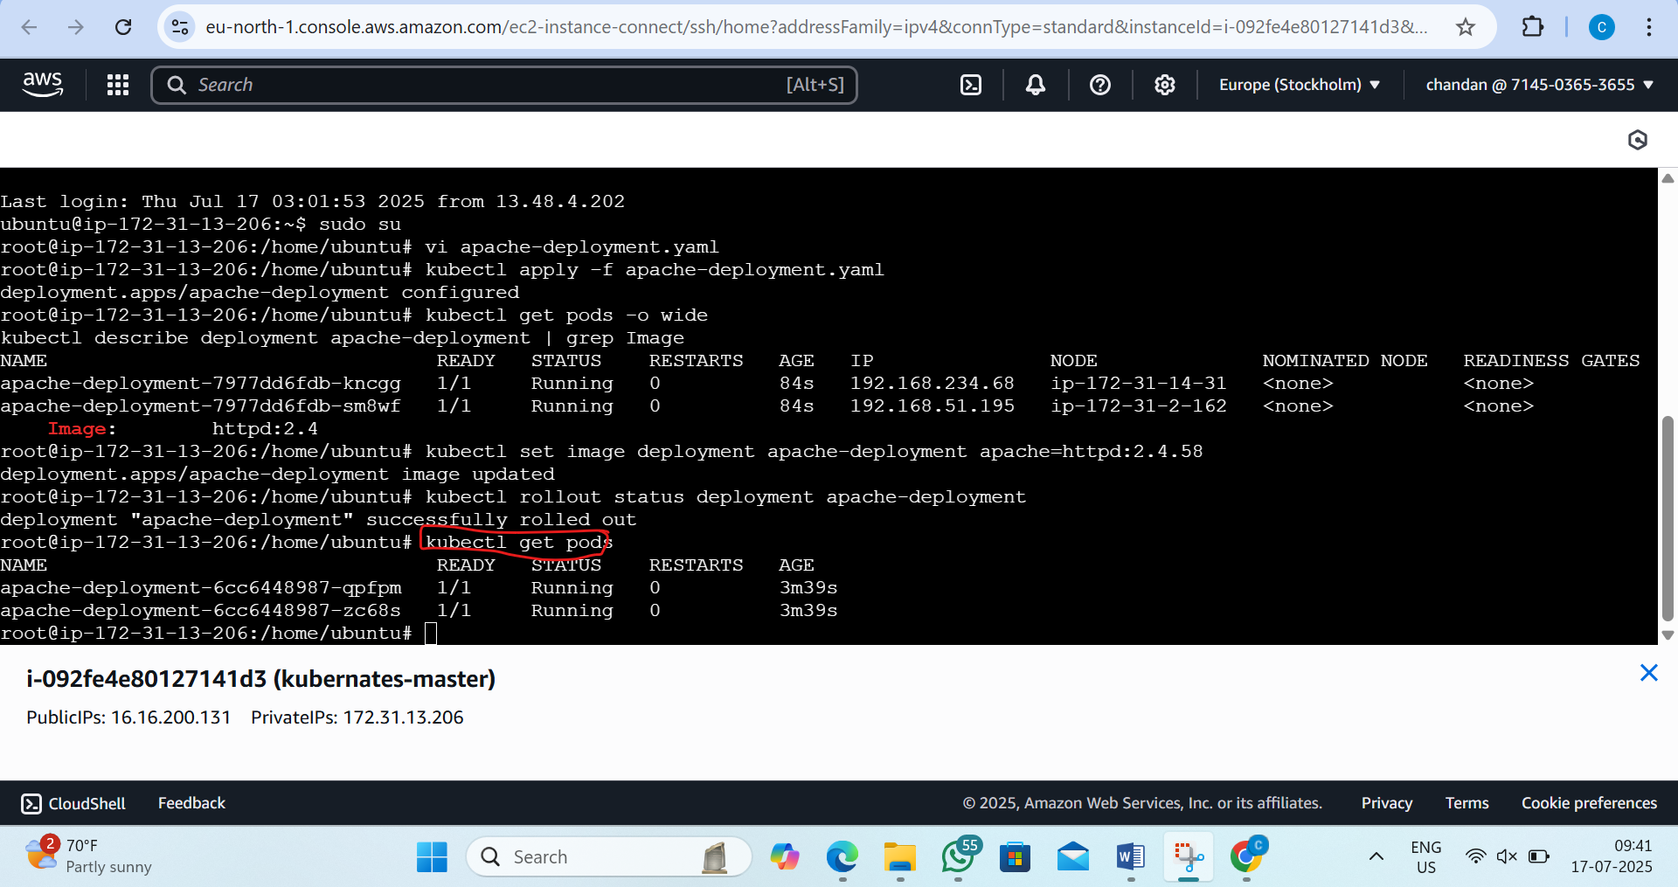

ii)now check the update images
by the command:- kubectl describe pod <one-of-the-pod-names>
hear:- kubectl describe pod apache-deployment-6cc6448987-qpfpm
